Newsletter n°11 – December 2020

CLASH! International Festival
The Hybrid in Dance Models, between Classic and Contemporary

THANK YOU!

Held from the 8th to the 13th of December 2020, CLASH! International Festival. The Hybrid in Dance Models, between Classic and Contemporary was an intense journey through dance that made possible a "virtual meeting" between different countries and European partners. Six events dedicated to dance were broadcasted every day on the official website clashproject.eu and on Facebook/Vimeo sharing the roundtables and the screendance performances produced by the partners involved in the project Clash! When Classic and Contemporary Dance Collide and New Forms Emerge, promoted by Balletto di Roma (Italy) and co-funded by Creative Europe Programme of the European Union.

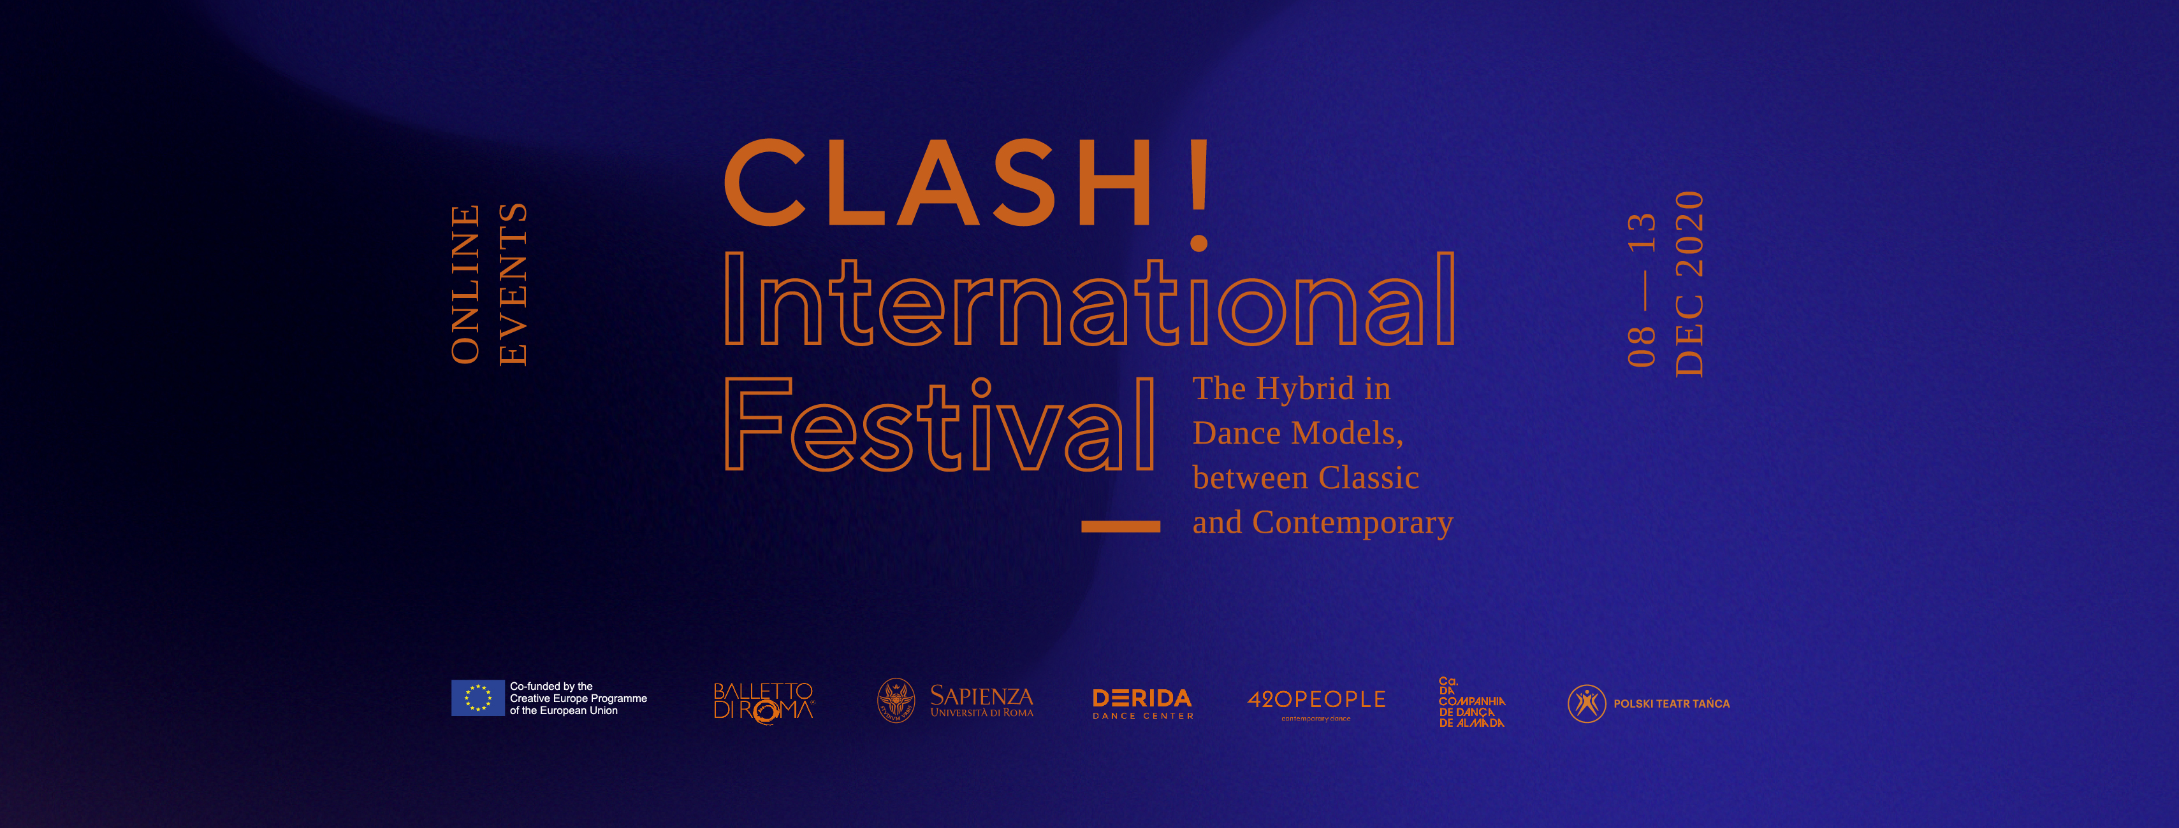

Coordinated by Sapienza University of Rome (Italy), every day of the CLASH! International Festival was curated by each partner-dance company - Balletto di Roma (Italy), 420PEOPLE (Czech Republic), Companhia de Dança de Almada (Portugal), Derida Dance Center / Art Link Foundation (Bulgaria), Polski Teatr Tanca/ Polish Dance Theater (Poland) - focusing on a particular issue explored along the project in the last two years.

RELIVE THE FESTIVAL ON VIMEO!
We are happy to announce that the videos of the Festival days are available on
https://vimeo.com/clashproject
users can request access by writing to office@clashproject.eu
During the Festival week, the online program was followed by hundreds of viewers, making also possible an interaction between users and producers thanks to the live chat on the social network. We want to thank all the audience who followed us online: thanks for your attention and for the wonderful comments.
A big thank you also goes to the Supporting Institutions that contributed to the realization and dissemination of the Festival.

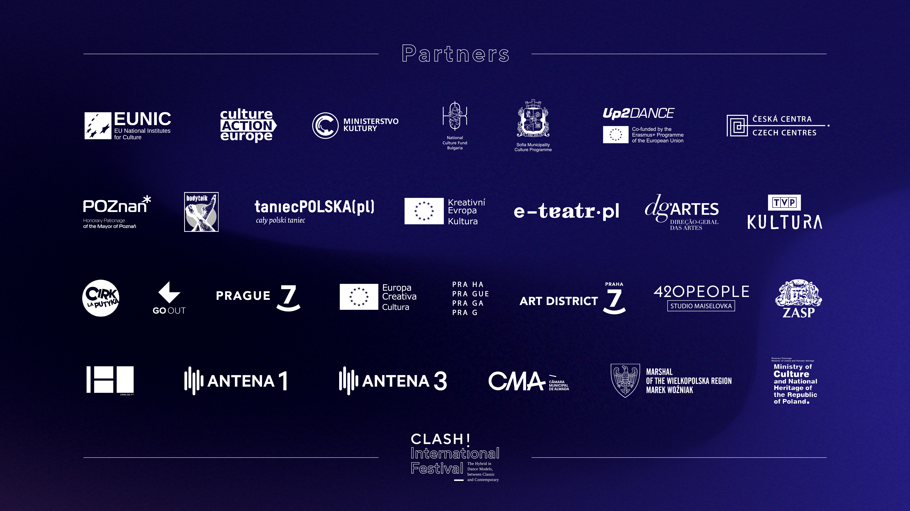

The Festival Days

The opening day was curated by 420PEOPLE: the presentation by the director Václav Kuneš was followed by a roundtable and a workshop on the topic of the Audience Development and the impact of pandemic. Keynote speakers: Petra Kašparová (420PEOPLE AD expert), Rosťa Novák (actor, director, performer, choreographer, founder and principal of the new circus ensemble Cirk La Putyka and artistic director of the multifunctional space Jatka78) and Lukáš Jandač (director of the international start-up project GoOut). Then, 420PEOPLE presented the screendance performance ORĪGĪ (direction, concept and choreography: Václav Kuneš; cinematography and postproduction: Tomáš Vlček; Dancers: Machovičová, Francesca Amante, Fanny Barrouquére).
Day 2 was curated by Polski Teatr Tańca: the theme of the day, presented by Iwona Pasińska (Director of PDT) and Agnieszka Jachym (dancer and coordinator of the CLASH! Project), was “Optimal Training for the Contemporary Dancer & Involvement of the Public in Dancer’s Everyday Life” discussed by the international choreographers, Václav Kuneš (Czech Republic), Maciej Kuźmiński (Poland) and Yoshiko Waki (Germany). Then, Polski Teatr Tańca presented the screendance performance Find the love in the dark (choreography: Davide Valrosso; artists-dancers of Polish Dance Theatre: Agnieszka Jachym, Jerzy Kaźmierczak, Zbigniew Kocięba; Music: Zbigniew Kozub; director of cinematography: Marek Grabowski; editing: Edyta Pietrowska).

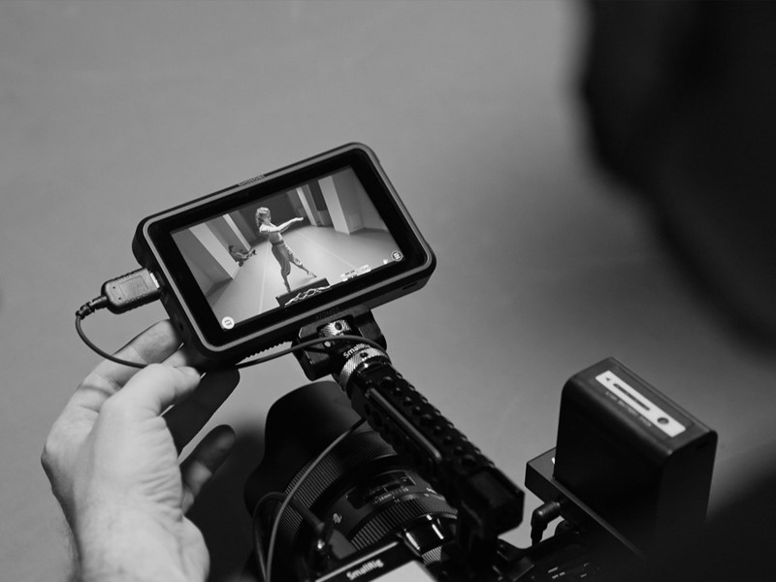

Day 3 was curated by Balletto di Roma: the theme of the day, presented by Luciano Carratoni (general manager Balletto di Roma), was “Hybrid Training for Today’s Dancers & New Training Path Strategies”. Keynote speakers: Francesca Magnini, artistic director Balletto di Roma, Valerio Longo, deputy artistic director, Andrea Costanzo Martini (international choreographer), Adriana Borriello (artistic director Da.Re) and Suzan Tunca (International Choreographic Arts Centre - ICK Amsterdam). Then, Balletto di Roma presented the screendance performance [dis]solution: choreographers from Polski Teatr Tanca: Agnieszka Jachym, Jerzy Kaźmierczak and Zbigniew Kocięba; dancers of Balletto di Roma: Giulia Strambini, Michele Ruggiero, Lorenzo Castelletta; assistant: Roberta De Simone; video: Matteo Carratoni; lights: Emanuele de Maria).

Day 4 was Curated by Derida Dance Centre / Art Link Foundation (Bulgaria): the theme of the day, presented by Atanas Maev (general manager of Derida Dance Center) and Milena Videnova (production assistant of Derida Dance Center), was “Culture Diplomacy as Tool for Better Achievements Before and After the New Normal”. Keynote speakers: Axenia Boneva (Ministry of Culture of Bulgaria), Desislava Pancheva (Culture contact point of Creative Europe desk), Stefka Tzaneva (Goethe institut, senior expert), Biliana Genova (Head of the Culture department of Sofia). Then, Derida Dance Centre presented the screendance performance Fractus (Choreographer: Jivko Jeliazkov; visual artist: Vladislav Iliev; composer: Ivan Shopov; dancers: Ivona Mashova, Simona Todorova, Philip Milanov, Vyara Bolgradova; project assistant: Isabel Mitkova; Camera: Nikolay Karasabev, Dimitаr Kunev, Alexаnder Genchev - blurb.video; Video editor: Nikolay Karasabev).

Day 5 was curated by Companhia de Dança de Almada: the theme of the day, presented by the artistic director, Ana Macara, was a focus on Creative Processes together with the authors of the different pieces presented in the festival: Vaclav Kunes (Czech Republic); Jivko Jeliazkov (Bulgaria); Davide Valrosso (Italy); Agnieszka Jachym, Jerzy Kazmierczak and Zbigniew Kocieba (Poland). The topic was investigated also trough the presentation of the dance piece Noir by Bruno Duarte, and its adaptation for the screen, by director Marta Romero (performance: Beatriz Rousseau, Bruno Duarte, Francisco Ferreira, Joana Puntel, Luís Malaquias, Mariana Romão and Raquel Tavares; cinematography and grading: Lluís Miras; music: Brenda Lee, Bruno Duarte, Davidson Jaconello and Martin Phipps).

In order to reflect on the impact of the pandemic on the performance field, the last day of the festival was dedicated to open a ground to exchange visions on the role digitalization can play to preserve the actualization of dance activities, and on the funding opportunities European programs will provide to sustain dance practitioners in the near future. Day 6 was curated by Sapienza University of Rome and Balletto di Roma: the theme of the day, “Experience: Lessons Learnt, New Paths and Perspectives”, was presented by Vito Di Bernardi (full professor - CLASH! project manager for Sapienza University of Rome). Keynote speakers: Letizia Gioia Monda (adjunct professor Sapienza University of Rome), Francesca Billi (CLASH! international relations), Marta Gutierrez Benet (Programme Manager, Erasmus+ programme coordination, Directorate General Education, Youth, Sport and Culture), Willibrord Sluijters (Head of unit REGIO/G.4 - Italy/Malta - Directorate General for Regional and Urban Policy), Pedro Velazquez (Deputy Head of the Creative Europe Unit, European Commission, Directorate General Education, Youth, Sport and Culture), Andrea Costanzo Martini (Guest Choreographer of Balletto di Roma), Cristina Da Milano (vice president of CAE - Culture Action Europe), Andreas Hannes (Artistic Programmer & Producer of Cinedans Fest), Ariella Vidach (choreographer, dance pedagogue, artistic director of AiEP/ Avventure in Elicottero Prodotti).
Then, Sapienza University of Rome presented the videodance performance The Hybrid in Dance Models. Visual Storytelling of Choreographic Creative Processes (directing and editing: Chiara Crupi; dramaturgy Letizia Gioia Monda; with audiovisual contributions by Balletto di Roma, 420PEOPLE, Polski Teatr Tańca, Companhia de Dança de Almada, Derida Dance Center).

CLASH! International Festival
The Hybrid in Dance Models, between Classic and Contemporary
Website | Facebook
Mail: comunicazione@ballettodiroma.com

In compliance with EU General Data Protection Regulation (GDPR) that came into effect on 25 May 2018, we hereby inform you that the personal data you provide to CLASH is included in a file managed by BALLETTO DI ROMA (Piazza San Giovanni Battista de La Salle 3/5 – 00165 Roma) as Data Controller, on behalf of the – EU funded project – CLASH's partners, and used exclusively for dissemination of professional communications, newsletters, events or promotions related to contemporary dance, organized directly by any of the CLASH! partners or by carefully selected third parties pursuing a wider understanding and promotion of Contemporary dance in Europe or abroad.
You may revoke the consent you have given us at any time; Likewise, you may exercise your rights of access, rectification, cancellation and opposition free of charge by sending your request accompanied by the copy or data of your Personal Number to the telephone number 00 06.90375236 email privacy@ballettodiroma.com or the address BALLETTO DI ROMA, with VAT Number (p.iva/cod.fisc.) 11205521005.
In order to view our privacy policy and/or information about your Personal Data, the purposes and the parties the Data is shared with, visit the website http://clashproject.eu/privacy/ or contact with comunicazione@ballettodiroma.com

